Blue Quality Studios
a passion for IT Communications
Overview
Document No: BQS-00001

psIMAlerts Version 1.0
Test Plan

TABLE OF CONTENTS
1. introduction 4
1.1. Document Purpose 4
1.2. Scope 4
2. OVERVIEW 5
2.1. Description 5
2.2. Features 5
3. TEST ENVIRONMENT 5
4. Testing streams 6
5. TestinG 6
5.1. Installation 6
5.1.1. Test-511-Typical Install 6
5.2. Single Target 13
5.2.1. Test-521-Single Target-AD Account 13
5.2.2. Test-522-Single Target-AD Group 16
5.2.3. Test-523-Single Target-RTC Pool 17
5.2.4. Test-524-Single Target-Exchange Server 20
5.2.5. Test-524-Single Target-Different Ids 22
5.3. Pipelining 24
5.3.1. Test-531-Pipeline-Strings 24
5.3.2. Test-532-Pipeline-CsAdUser 26
5.3.3. Test-533-Pipeline-Text Files 27
5.4. Templates 28
5.4.1. Test-541-Templates-All 29
5.5. Documentation location 32
6. DOCUMENT CONTROL SHEET 33

introduction

Document Purpose
The document is for beta testers reviewing Blue Quality Studios psIMAlerts solution.

Scope
The document contains test scenarios and instructions. Readers are encouraged to visit the Blue Quality Studios website for an overview and examples of psIMAlerts before reading this document

OVERVIEW

Description
psIMAlerts is a Powershell® CmdLet (Send-Alerts) for IT Administrators to send bulk Instant Messages to either Microsoft Lync or Microsoft Communicator 2007R2. psIMAlerts is installed on the Microsoft Lync 2010 or Microsoft Office Communications 2007 R2 server. There is no software installed on the desktops. Messages can be either a plain text or rich HTML message. Recipients can be a single Active Directory account, all members of an Active Directory group (including nested group members), members of an Exchange server or RTC Pool. In addition recipients can be provided by pipelining (single text file or object stream from another CmdLet).

Features
The solution has the following features:
- Build-in message templates including “Winning”, “Success” and “UpAndUp”
- Result report of recipients that did receive the alert
- As a trusted application send from an account (resource account recommended)
- No limit to number of recipients
- Support for pipelining recipients
- Recipient id can be login id, display name, email address or SIP URI
- Recipients can be supplied by providing an Active Directory group id
- Recipients can be members of an Exchange server or an RTC pool
- Set the message priority as either: Urgent, Normal, Non-urgent

TEST ENVIRONMENT
The solution has the following components:
Active Directory Domain Controller
All test and production scenario require a Microsoft Active Directory Domain Controller running on Windows 2003 or later.
Microsoft Real-Time Server
psIMlert is support running on either the standard edition version of either Microsoft Lync Server 2010 or Microsoft Office Communications Server 2007R2. Beta testers are encourage to try bother scenarios
(optional) Microsoft Exchange Server 2010
psIMAlerts can be used to send to members of an Exchange server . An option exists to provide alternate Active Directory account credentials of an Exchange View-Only or greater Administrator during a custom installation or as an optional to the CmdLet to be used for mailbox membership lookup.
(optional) Desktops
As the Microsoft Lync or Microsoft Communicator 2007R2 can operator on the RTC server or the web client (CWA) can be used for testing this component is optional.

Testing streams
This test plan has the following streams:

Name | Description
Installation | The install wizard can install on either Lync or OCS 2007R2 with Typical or Custom options .
Single Target | The ‘Identity’ option can be supplied the Id of an AD account or group.
Pipelining | Recipients can be supplied as a stream of objects (including string) through the pipeline.
Templates | There are more than 12 built-in messages templates which can be customised.

TestinG

Installation
In this stream we will add the software to the RTC server (either Lync Server 2010 or OCS2007R2) using the Typical mode. The common installer detects the version of RTC server software and installs the appropriate runtimes.
The install is
Setup-psIMAlerts-StdEdition-V1-x64.exe
And is available from http://www.bluequalitystudios.com.au/s01/download. You must have a valid email address to receive the email invitation. The invitation contains a unique download link which is available for up to 14 days.
Prerequisites:
- Windows Server 2003 or later (64 bit editions only)
- Microsoft Office Communications Server 2007R2 or Microsoft Lync Server 2010 (Standard Editions only).
- Microsoft Powershell (Version 1.0 or later)
- Be a local Administrator of the server
- Be an RTC Server Administrator (member of RTCWriteServerAdmins)

Test-511-Typical Install
Overview
In this test we will install psIMAlerts using the Typical settings.
What’s Happening
In phase 1 the prerequisites are checked. If any fail an optional dialog is displayed showing the actions to complete. When the dialog is closed the installer closes.

In Phase 2 a check is made of earlier version of the psIMAlerts software and if detect a prompt is shown to remove the software before proceeding.

In Phase 3 the installer file extracts an .MSI file to a newly created cache folder:
c:\ProgramData\BlueQualityStudios\psIMAlerts\cache (Windows Server 2008)
or
c:\Documents and Settings\All Users\Application Data\ … (Windows Server 2003)

In Phase 4 the installer run the .MSI showing a progress bar as files appear on disk under c:\Program Files\Blue Quality Studios\psIMAlerts. Some custom START menu shortcuts are created in this phase.

Once the install is completed the progress bar is at 100% and a Next button is provided. Once select the Setup.exe program launches the Config.exe utility and initial Setup.exe shuts down. As the two wizards are similar in look the handoff is not noticed. Config.exe has some runtime support DLLs that are not present before the .MSI is run.

Testing Steps
Steps to complete this test:
- Copy the setup EXE file
Setup-psIMAlerts-StdEdition-V1-x64.exe
to the RTC server in to the folder
c:\install\psIMAlerts
- Logon to the server as a Local Administrator and member of the RTCWriteServerAdmins group.
- Start c:\install\psIMAlerts\Setup-psIMAlerts-StdEdition-V1-x64.exe
- On the Introduction dialog select Next.

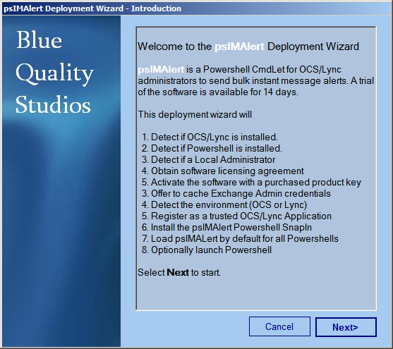
- On the Licensing Agreement Acknowledgement dialog select I accept these terms and select Next. sselect Next.
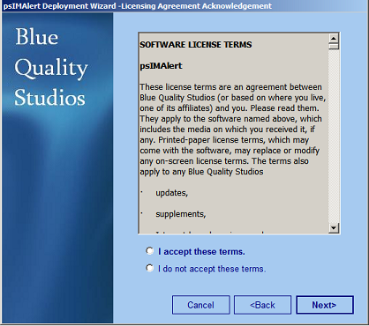
- If psIMAlerts has been install previous the following optional dialog will appear. Select Yes if it appears.
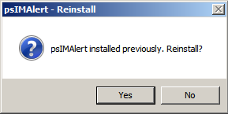
- On the Installing dialog once the software is installed select Next.
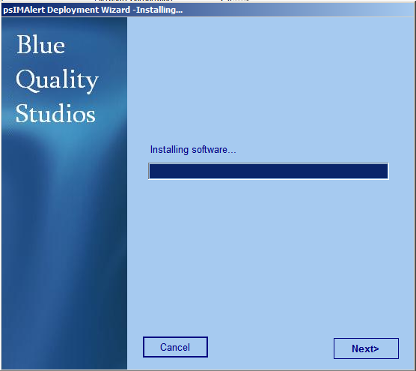
- On the Activation dialog select Next.
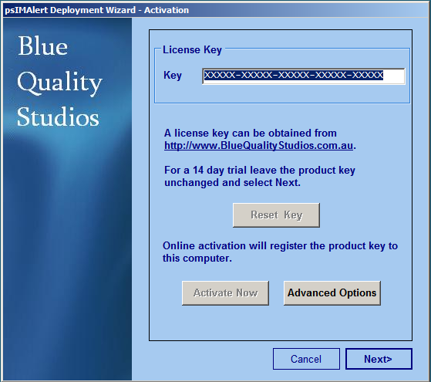
- On the Mode dialog select Next
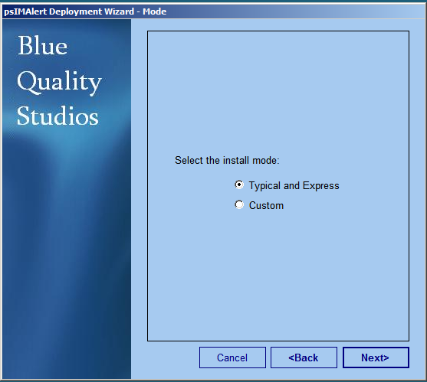
- On the Outcomes dialog select Finish
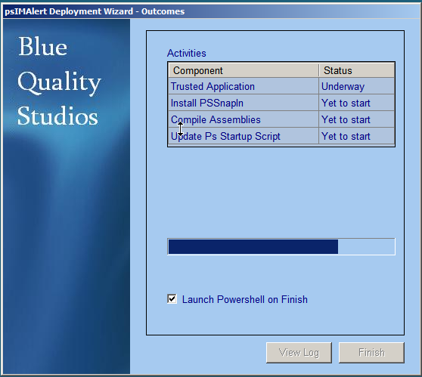
Comments and Rating
Provide your review of the test. Score the quality of the experience.

1. Did you experience any error messages (Yes/No)? ____ Comments: __________________
2. Were the installation instructions clear (Yes/No)? ____ Comments: __________________
3. Was the install speed acceptable (Yes/No)? ____ Comments: __________________
4. What was your overall impression of the install (0-Terrible, 5- Fair, 10-Excellent)? ____
Comments: _______________________________________________________

Outcomes
The following are steps to measure the outcome of this test.

511-Outcomes-001: Programs Folder
- Start a CMD Window.
- At the prompt enter: cd “C:\Program Files\Blue Quality Studios\psIMAlert”
- At the prompt enter: dir /os
- Record the number of files in position (1) in the table below.
- At the prompt enter: dir /os
- Record the number of directories in position (2) in the table below.
- Close the CMD Window

511-Outcomes-002: ProgramData Folder
- Start a CMD Window.
- At the prompt enter for Windows Server 2008 enter:
cd “C:\ProgramData\Blue Quality Studios\psIMAlert”
or for Window Server 2003 enter
cd “C:\Documents And Settings\All Users\Blue Quality Studios\psIMAlert”

- At the prompt enter. type DefaultSipDomain.Cache
- Record the contents of file in position (3) in the table below.
- At the prompt enter. notepad log\Setup\Deployment.log
- Email the contents of the log file to info@BlueQualityStudios.com.au with a subject line of BQS-psIMAlert-Install-Testing.
- Search for the word “Exception”. Record the number of occurrences in in position (4).
- Search for the phrase “Failed to”. Record the number of occurrences in in position (5).

511-Outcomes-003: Programs Folder
- Open the Control Panel.
- Select Add/Remove Programs or Programs and Features.
- Record the size of installation in position (6) in the table below.
- Close all

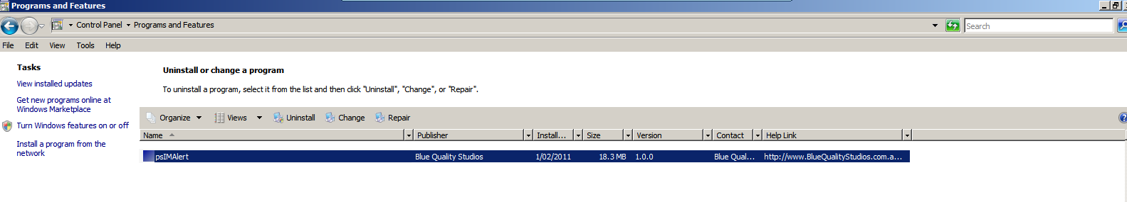
511-Outcomes-004: START menu shortcuts
- Select START, All Programs , Blue Quality Studios, psIMAlert.
- The shortcuts should be the same as the screenshot below. Record any differences in position (7) in the table below

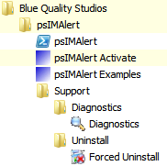

511-Outcomes-005: Diagnostics
- Select START, All Programs , Blue Quality Studios, psIMAlert, Support, Diagnostics folder then select the Diagnostics shortcut
- Record the psIMAlert Port number in position (8) in the table below

Attribute Value
--------- -----
RTC Server Version Microsoft Lync Server 2010
Machine Name LYNC0001
Machine FQDN LYNC0001.bqs.com.au
OS Microsoft® Windows Server® 2008 Enterprise
OS SP 2
Timezone Name E. Australia Standard Time
Timezone UTC Offset 10:00:00
Domain Root DC=csi10,DC=in,DC=bqs,DC=com,DC=au
Domain Controller DC0001.bqs.com.au
DC Functionality 3
Domain Functionality 3
Forest Functionality 3
Global AD Config Container Forest Config (New)
Pool BackEnd LYNC0001.bqs.com.au\rtc
Pool Domain FQDN LYNC0001.bqs.com.au
RTC Service Account NT AUTHORITY\NetworkService
RtcSvc.Exe Version 4.0.7577.0 built by: lcs_se_w14_main(rtbldlab)
Powershell Runtime Version v2.0.50727
Powershell.Exe Version 6.0.6002.18111 (vistasp2_gdr_win7ip_winman(wmbla)...
Common App Data C:\ProgramData
Activation Date 01/01/1601 10:00:00
Program Files C:\Program Files
psIMAlert Version 1.0.0.0
psIMAlert Host FQDN Lync001.bqs.com.au
psIMAlert AD cn {efcc8fda-9af7-424b-84e7-4a3e74f6227f}
psIMAlert Port 10999
psIMAlert GruuId {55070f35-6c91-526e-a7a2-e3dcaaa44522}
psIMAlert Host FQDN LYNC0002.bqs.com.au
psIMAlert AD cn {ac179980-67d2-4758-a90e-988cc2f20c2e}
psIMAlert Port 10999
psIMAlert GruuId {8df90388-b865-51f5-8a73-a002826177fb}
Default SIP Domain bqs.com.au

TRG TrustedApplicationName ServerName P
o
r
t
--- ---------------------- ---------- -

QoS LYNC0001.bqs.com.au 5
Microsoft.Rtc.Applications.TestBot LYNC0001.bqs.com.au 5
Microsoft.Rtc.Applications.Cps LYNC0001.bqs.com.au 5
Microsoft.Rtc.Applications.Acd LYNC0001.bqs.com.au 5
Microsoft.Rtc.Applications.PDP LYNC0001.bqs.com.au 5
MediationServer LYNC0001.bqs.com.au 5
QoS LYNC0002.bqs.com.au 5
Microsoft.Rtc.Applications.TestBot LYNC0002.bqs.com.au 5
* psimalert LYNC0001.bqs.com.au 1
* psimalert LYNC0002.bqs.com.au 1

PS C:\Program Files\Blue Quality Studios\psIMAlert\Support\Diagnostics>

 | Description | Expected | Measured
1 | Number of files | 18
2 | Number of directories | 8
3 | Default SIP Domain | <company>.com
4 | Exceptions | 0
5 | Failed to | 0
6 | Size | 18.3MB
7 | Start menu | 3 top shortcuts  1 support folder  1 Diagnostics  1 Forced Uninstall
8 | psIMAlert Port | 10999

Comments on measurements: ___________________________________________________
____________________________________________________________________________
____________________________________________________________________________
____________________________________________________________________________

Single Target
In this stream we will send an IM Alert to a single target. A target can be a single AD account or an AD group, Exchange Server or RTC pool.
In our first two tests we will use the ‘Identity’ option; first to specify a single account and then an AD group.
In test 3 we will use the ‘PoolName’ option to target all accounts on our RTC pool (either Lync Server or OCS 2007 R2).
Test 4 is (optional) it requires Exchange 2003 server in the test environment. In this test we will use the ‘ExchangeServer’ option to target all accounts on our email server.

Test-521-Single Target-AD Account
Overview
In this test we will use the psIMAlert Target Script Generator to target a single AD account using a HTML template.

What’s Happening
psIMAlerts is a Powershell® snapin which registered each time a Powershell® session starts. The 64 bit assembly used is on Lync Server is
c:\program files\Blue Quality Studios\psIMAlerts\psIMAlert.DLL
or on OCS 2007 R2 is
c:\program files\Blue Quality Studios\psIMAlerts\ocs2007R2\psIMAlert.DLL

During installation psIMAlerts is registered as a trusted application. It therefore logon and send as an account. It is recommended however that a resource account that is not usually used for IM be created and used. By default the from SIP address is IMAlerts@<default sip domain>. To specify from From account use the ‘From’ option.

The recipient can be specified using the login id, display name, email address, SIP URI or DN of the account used the ‘Identity’ option. Several directory lookups are performed to find the account.

The HTML message template files are located under
c:\program files\Blue Quality Studios\psIMAlerts\HTMLTemplates
The ‘HTMLtemplateFName’ option can take a full path name, a file name with extension of just the base file name. If the full path is not specified the default HTMLTemplates is used.

psIMAlerts will start an IM session with RTC server using the GUID, port, name and digital certificate to attach. The session is used to establish a point of presence for the From account.

A new IM conversation is started with the recipient. The HTML template message is read and text is replaced.

Testing Steps
Steps to complete this test:

- Select START, All Programs, Blue Quality Studios, psIMAlert, psIMAlert Examples
- At the prompt enter: .\ 1-SimpleTarget.ps1
- To the question of which template enter: 4
- To the question of which target enter the login Id of an AD account.
Warning: if you are doing this test in a production environment this account will get a test IM.
- To the question of message text press enter to accept the default text.
- To the question of subject line press enter to accept the default text.
- To the question of sender press enter to accept the default account or enter a SIP URI.
Warning: it is recommend to provide a resource account that does not use IM.
- The Powershell® script is generated, displayed and executed.

Windows PowerShell
Copyright (C) 2009 Microsoft Corporation. All rights reserved.

PS C:\Program Files\Blue Quality Studios\psIMAlert\Examples> .\1-SimpleTarget.ps1

psIMAlert Examples

# Single Target Script Generator
#
.\Examples\1-SingleTaget.ps1
#
#
More examples at http://www.BlueQualityStudios.com.au/s01/psIMAlertExamples.html

PS C:\Program Files\Blue Quality Studios\psIMAlert\Examples> .\1-SimpleTarget.ps
1
psIMAlert Single Target Script Generator

# Select one of the message styles/template.
# 1-Email Outage, 2-IM Outage, 3-Test, 4-Announcement 004
Message Template [4-Announcement 004]: 4
# Select the recipient(s) by provided a Target Id.
# A target Id can be the id of an AD group or single AD account.
#
# The target id can be a SIP URI, email address, Login Id or Display Name.
# If a group id then all members (including nested members) will be recipients.
Enter Single Target Id: fredN
# Enter the text of the message.
Message Text [Test Message]:
# Enter the Subject Line of the message
Subject Line [Test Message]:
# Enter the URI of the Sender
# The sender should be a resource account that is not normally logged on
Sender [imAlerts@bqs.com.au]:
# The powershell command generated is:
Send-Alert -Identity fredN -SubjectLine "Test Message" -Priority Urgent -Messa
geHtmlTemplateFName "Annoucement004" -HtmlMessageText "Test Message" -From imAlerts@bqs.com.au
# Executing the command

Datetime ResponseCode Uri
-------- ------------ ---
1/02/2011 3:07:38 PM 0 sip:fred.natzke@bqs.com.au

PS C:\Program Files\Blue Quality Studios\psIMAlert\Examples>

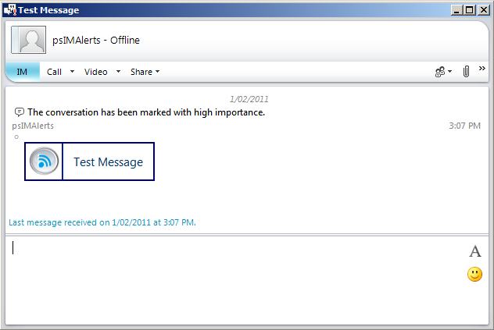

Comments and Rating
Provide your review of the test. Score the quality of the experience.

1. Did you experience any error messages (Yes/No)? ____ Comments: __________________
2. Were the instructions clear (Yes/No)? ____ Comments: __________________
4. What was your overall impression of the test (0-Terrible, 5- Fair, 10-Excellent)? ____
Comments: _______________________________________________________

Test-522-Single Target-AD Group
Overview
In this test we will use the psIMAlert Target Script Generator to target a single AD group using a HTML template.

What’s Happening
To specify a group the target id supplied to the ‘Identity’ option can be the group legacy id (samAccountName), display name, or DN. Members of any nested groups will also be included.

Testing Steps
Steps to complete this test:

- Select START, All Programs, Blue Quality Studios, psIMAlert, psIMAlert Examples
- At the prompt enter: .\ 1-SimpleTarget.ps1
- To the question of which template enter: 4
- To the question of which target enter the login Id of an AD group.
Warning: if you are doing this test a production environment group members will get a test IM.
- To the question of message text press enter to accept the default text.
- To the question of subject line press enter to accept the default text.
- To the question of sender press enter to accept the default account or enter a SIP URI.
Warning: it is recommend to provide a resource account that does not use IM.
- The Powershell® script is generated, displayed and executed.

Windows PowerShell
Copyright (C) 2009 Microsoft Corporation. All rights reserved.

PS C:\Program Files\Blue Quality Studios\psIMAlert\Examples> .\1-SimpleTarget.ps1

psIMAlert Examples

# Single Target Script Generator
#
.\Examples\1-SingleTaget.ps1
#
#
More examples at http://www.BlueQualityStudios.com.au/s01/psIMAlertExamples.html

PS C:\Program Files\Blue Quality Studios\psIMAlert\Examples> .\1-SimpleTarget.ps
1
psIMAlert Single Target Script Generator

# Select one of the message styles/template.
# 1-Email Outage, 2-IM Outage, 3-Test, 4-Announcement 004
Message Template [4-Announcement 004]: 4
# Select the recipient(s) by provided a Target Id.
# A target Id can be the id of an AD group or single AD account.
#
# The target id can be a SIP URI, email address, Login Id or Display Name.
# If a group id then all members (including nested members) will be recipients.
Enter Single Target Id: dl0001
# Enter the text of the message.
Message Text [Test Message]:
# Enter the Subject Line of the message
Subject Line [Test Message]:
# Enter the URI of the Sender
# The sender should be a resource account that is not normally logged on
Sender [imAlerts@bqs.com.au]:
# The powershell command generated is:
Send-Alert -Identity dl0001 -SubjectLine "Test Message" -Priority Urgent -Messa
geHtmlTemplateFName "Annoucement004" -HtmlMessageText "Test Message" -From imAlerts@bqs.com.au
# Executing the command

Datetime ResponseCode Uri
-------- ------------ ---
1/02/2011 3:07:38 PM 0 sip:fred.natzke@bqs.com.au
1/02/2011 3:07:38 PM 0 sip:mark.lane@bqs.com.au
1/02/2011 3:07:38 PM 0 sip:richard.hill@bqs.com.au
1/02/2011 3:07:38 PM 0 sip:mary.streeter@bqs.com.au
1/02/2011 3:07:39 PM 0 sip:bill.bones@bqs.com.au

PS C:\Program Files\Blue Quality Studios\psIMAlert\Examples>

Comments and Rating
Provide your review of the test. Score the quality of the experience.

1. Did you experience any error messages (Yes/No)? ____ Comments: __________________
2. Were the instructions clear (Yes/No)? ____ Comments: __________________
4. What was your overall impression of the test (0-Terrible, 5- Fair, 10-Excellent)? ____
Comments: _______________________________________________________

Test-523-Single Target-RTC Pool
Overview
In this test we will use the psIMAlert Target Script Generator to target a RTC Pool either Lync Server or OCS2007R2. The pool target can be Enterprise or Standard edition.

What’s Happening
To specify a group the target id supplied to the ‘Identity’ option can be the group legacy id (samAccountName), display name, or DN. Members of any nested groups will also be included.

Testing Steps
Steps to complete this test:

- Select START, All Programs, Blue Quality Studios, psIMAlert, psIMAlert Examples
- At the prompt enter: .\ 1-SimpleTarget.ps1
- To the question of which template enter: 2
- To the question of Pool Name for OCS 2007 R2 enter the short pool name (eg. Pool001) or LyncServer use the SiteId:PoolId (eg: 1:1 would be pool 1 in site 1)
Warning: if you are doing this test in a production environment many accounts will get a test IM.
- To the question of message text press enter to accept the default text.
- To the question of subject line press enter to accept the default text.
- To the question of sender press enter to accept the default account or enter a SIP URI.
Warning: it is recommend to provide a resource account that does not use IM.
- The Powershell® script is generated, displayed and executed.

Windows PowerShell
Copyright (C) 2009 Microsoft Corporation. All rights reserved.

PS C:\Program Files\Blue Quality Studios\psIMAlert\Examples> .\1-SimpleTarget.ps1

psIMAlert Examples

# Single Target Script Generator
#
.\Examples\1-SingleTaget.ps1
#
#
More examples at http://www.BlueQualityStudios.com.au/s01/psIMAlertExamples.html

PS C:\Program Files\Blue Quality Studios\psIMAlert\Examples> .\1-SimpleTarget.ps
1
psIMAlert Single Target Script Generator

# Select one of the message styles/template.
# 1-Email Outage, 2-IM Outage, 3-Test, 4-Announcement 004
Message Template [4-Announcement 004]: 2
# Enter the pool name of the Lync or OCS.
# All accounts of this pool will be recipients.
Enter short name of the Pool Name: 1:1
# Enter the text of the message.
Message Text [Message Text [Your corporate Instant Messaging Server is scheduled to go <b>offl
ine</b> for 1 hour for scheduled maintenance in 10 minutes. Please complete any
conversations.<a href='http://www.bqs.com.au\ImOutageDetails.html'>
Read more.</a>]:
# Enter the Subject Line of the message
Subject Line [IM Outage]:
# Enter the URI of the Sender
# The sender should be a resource account that is not normally logged on
Sender [imAlerts@bqs.com.au]:
# The powershell command generated is:
Send-Alert -PoolName 1:1 -SubjectLine "IM Outage" -Priority Urgent -MessageHtmlT
emplateFName "rtcAlert.html" -HtmlMessageText "Your corporate Instant Messaging Server is schedule
d to go <b>offline</b> for 1 hour for scheduled maintenance in 10 minutes. Pleas
e complete any conversations.<a href='http://www.bqs.com.au\ImOutag
eDetails.html'>Read more.</a>" -From imAlerts@bqs.com.au
# Executing the command

Datetime ResponseCode Uri
-------- ------------ ---
1/02/2011 3:17:38 PM 0 sip:fred.natzke@bqs.com.au
1/02/2011 3:17:38 PM 0 sip:mark.lane@bqs.com.au
1/02/2011 3:17:38 PM 0 sip:richard.hill@bqs.com.au
1/02/2011 3:17:38 PM 0 sip:mary.streeter@bqs.com.au
1/02/2011 3:17:39 PM 0 sip:bill.bones@bqs.com.au

PS C:\Program Files\Blue Quality Studios\psIMAlert\Examples>

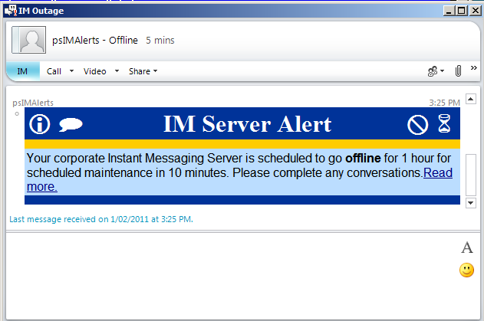

Comments and Rating
Provide your review of the test. Score the quality of the experience.

1. Did you experience any error messages (Yes/No)? ____ Comments: __________________
2. Were the instructions clear (Yes/No)? ____ Comments: __________________
4. What was your overall impression of the test (0-Terrible, 5- Fair, 10-Excellent)? ____
Comments: _______________________________________________________

Test-524-Single Target-Exchange Server
Overview
In this test we will use the psIMAlert Target Script Generator to target an Exchange Server.

What’s Happening
To specify a group the target id supplied to the ‘Identity’ option can be the group legacy id (samAccountName), display name, or DN. Members of any nested groups will also be included.

Testing Steps
Steps to complete this test:

- Select START, All Programs, Blue Quality Studios, psIMAlert, psIMAlert Examples
- At the prompt enter: .\ 1-SimpleTarget.ps1
- To the question of which template enter: 1
- To the question of short Exchange server name (eg. Exch0001)
Warning: if you are doing this test in a production environment many accounts will get a test IM.
- To the question of message text press enter to accept the default text.
- To the question of subject line press enter to accept the default text.
- To the question of sender press enter to accept the default account or enter a SIP URI.
Warning: it is recommend to provide a resource account that does not use IM.
- The Powershell® script is generated, displayed and executed.

Windows PowerShell
Copyright (C) 2009 Microsoft Corporation. All rights reserved.

PS C:\Program Files\Blue Quality Studios\psIMAlert\Examples> .\1-SimpleTarget.ps1

psIMAlert Examples

# Single Target Script Generator
#
.\Examples\1-SingleTaget.ps1
#
#
More examples at http://www.BlueQualityStudios.com.au/s01/psIMAlertExamples.html

PS C:\Program Files\Blue Quality Studios\psIMAlert\Examples> .\1-SimpleTarget.ps
1
psIMAlert Single Target Script Generator

# Select one of the message styles/template.
# 1-Email Outage, 2-IM Outage, 3-Test, 4-Announcement 004
Message Template [4-Announcement 004]: 1
# Enter the short name (NetBIOS) of the Exchange server.
# All accounts with mailboxes on this exchange server will be recipients..
Enter short name of the Exchange Server: Exch0001
# Enter the text of the message.
Message Text [Your corporate email server ({ExchangeServerName}) is scheduled to
go <b>offline</b> for 1 hour for scheduled maintenance in 10 minutes. Please s
ave any draft emails. Email sent to you will be delayed until service is restore
d. <a href='http://www.bqs.com.au\emailOutageDetails.html'>Read mor
e.</a>]:
# Enter the Subject Line of the message
Subject Line [Email Outage]:
# Enter the URI of the Sender
# The sender should be a resource account that is not normally logged on
Sender [imAlerts@bqs.com.au]:
# The powershell command generated is:
Send-Alert -ExchangeServerName Exch0001 -SubjectLine "Email Outage" -Priority Ur
gent -MessageHtmlTemplateFName "EmailAlert" -HtmlMessageText "Your corporate email server ({ExchangeServerName}) is scheduled to go <b>offline</b> for 1 hour for scheduled maintenance in 10 minutes. Please save any draft emails. Email sent to you willbe delayed until service is restored. <a href='http://www.bqs.com.a
u\emailOutageDetails.html'>Read more.</a>" -From imAlerts@bqs.com.au
# Executing the command

Datetime ResponseCode Uri
-------- ------------ ---
1/02/2011 3:27:38 PM 0 sip:fred.natzke@bqs.com.au
1/02/2011 3:27:38 PM 0 sip:mark.lane@bqs.com.au
1/02/2011 3:27:38 PM 0 sip:richard.hill@bqs.com.au
1/02/2011 3:27:38 PM 0 sip:mary.streeter@bqs.com.au
1/02/2011 3:27:39 PM 0 sip:bill.bones@bqs.com.au

PS C:\Program Files\Blue Quality Studios\psIMAlert\Examples>

Comments and Rating
Provide your review of the test. Score the quality of the experience.

1. Did you experience any error messages (Yes/No)? ____ Comments: __________________
2. Were the instructions clear (Yes/No)? ____ Comments: __________________
4. What was your overall impression of the test (0-Terrible, 5- Fair, 10-Excellent)? ____
Comments: _______________________________________________________

Test-524-Single Target-Different Ids
Overview
In this test we will target the same recipient but use different unique names.
psIMAlert supports the following Active Directory attributes:
login Id (samaccountname),
Display Name (displayname),
Email Address (mail),
SIP URI (msrtcsip-primaryuseraddress),
Active Directory Distinguished Name (DN) (distinguishedName)
Legacy Exchange DN (legacyExchangeDn)

What’s Happening
A series of Active Directory lookups are perform to unique discover a target.

Testing Steps
Steps to complete this test:

- Select START, All Programs, Blue Quality Studios, psIMAlert, psIMAlert Examples
- At the prompt enter: csvde

- At the prompt enter: .\ 1-SimpleTarget.ps1
- To the question of which template enter: 1
- To the question of short Exchange server name (eg. Exch0001)
Warning: if you are doing this test in a production environment many accounts will get a test IM.
- To the question of message text press enter to accept the default text.
- To the question of subject line press enter to accept the default text.
- To the question of sender press enter to accept the default account or enter a SIP URI.
Warning: it is recommend to provide a resource account that does not use IM.
- The Powershell® script is generated, displayed and executed.

Windows PowerShell
Copyright (C) 2009 Microsoft Corporation. All rights reserved.

PS C:\Program Files\Blue Quality Studios\psIMAlert\Examples> .\1-SimpleTarget.ps1

psIMAlert Examples

# Single Target Script Generator
#
.\Examples\1-SingleTaget.ps1
#
#
More examples at http://www.BlueQualityStudios.com.au/s01/psIMAlertExamples.html

PS C:\Program Files\Blue Quality Studios\psIMAlert\Examples> .\1-SimpleTarget.ps
1
psIMAlert Single Target Script Generator

# Select one of the message styles/template.
# 1-Email Outage, 2-IM Outage, 3-Test, 4-Announcement 004
Message Template [4-Announcement 004]: 1
# Enter the short name (NetBIOS) of the Exchange server.
# All accounts with mailboxes on this exchange server will be recipients..
Enter short name of the Exchange Server: Exch0001
# Enter the text of the message.
Message Text [Your corporate email server ({ExchangeServerName}) is scheduled to
go <b>offline</b> for 1 hour for scheduled maintenance in 10 minutes. Please s
ave any draft emails. Email sent to you will be delayed until service is restore
d. <a href='http://www.bqs.com.au\emailOutageDetails.html'>Read mor
e.</a>]:
# Enter the Subject Line of the message
Subject Line [Email Outage]:
# Enter the URI of the Sender
# The sender should be a resource account that is not normally logged on
Sender [imAlerts@bqs.com.au]:
# The powershell command generated is:
Send-Alert -ExchangeServerName Exch0001 -SubjectLine "Email Outage" -Priority Ur
gent -MessageHtmlTemplateFName "EmailAlert" -HtmlMessageText "Your corporate email server ({ExchangeServerName}) is scheduled to go <b>offline</b> for 1 hour for scheduled maintenance in 10 minutes. Please save any draft emails. Email sent to you willbe delayed until service is restored. <a href='http://www.bqs.com.a
u\emailOutageDetails.html'>Read more.</a>" -From imAlerts@bqs.com.au
# Executing the command

Datetime ResponseCode Uri
-------- ------------ ---
1/02/2011 3:27:38 PM 0 sip:fred.natzke@bqs.com.au
1/02/2011 3:27:38 PM 0 sip:mark.lane@bqs.com.au
1/02/2011 3:27:38 PM 0 sip:richard.hill@bqs.com.au
1/02/2011 3:27:38 PM 0 sip:mary.streeter@bqs.com.au
1/02/2011 3:27:39 PM 0 sip:bill.bones@bqs.com.au

PS C:\Program Files\Blue Quality Studios\psIMAlert\Examples>

Comments and Rating
Provide your review of the test. Score the quality of the experience.

1. Did you experience any error messages (Yes/No)? ____ Comments: __________________
2. Were the instructions clear (Yes/No)? ____ Comments: __________________
4. What was your overall impression of the test (0-Terrible, 5- Fair, 10-Excellent)? ____
Comments: _______________________________________________________

Pipelining
In this stream we will specify recipients based on input from the pipeline. Pipeline input is a sequence of objects. The simplest object is a string. A more complex object contains properties. psIMAlerts can detect well known properties names on objects. psIMAlerts looks for the following property names:
legacyexchangedn
distinguishedname
legacydn
samaccountname
msrtcsip-primaryuseraddress
displayname
mailnickname
userprincipalname
A more complex object again is a sequence of array objects. Each array contains a collection of objects which could in turn be a sequence of array objects.

Test-531-Pipeline-Strings
Overview
In this test we will specify the list of recipients using a sequence of strings.

What’s Happening
A detect of a basic string object type. A lookup of various Active Directory attributes to find a unique match.

Testing Steps
Steps to complete this test:

- Select START, All Programs, Blue Quality Studios, psIMAlert, psIMAlert Examples
- At the prompt enter: .\ 4-Array.ps1
- To the question of which template enter: Announcement004
- To the question of “Recipient Target Id” enter either the login id, display name , email address or SIP URI of a target account.
Warning: if you are doing this test in a production environment many accounts will get a test IM.
- Repeat step 4 for several Ids. Once all Ids are entered press enter for a blank entry.
- To the question of message text press enter to accept the default text.
- To the question of subject line press enter to accept the default text.
- To the question of sender press enter to accept the default account or enter a SIP URI.
Warning: it is recommend to provide a resource account that does not use IM.
- The Powershell® script is generated, displayed and executed.

Windows PowerShell
Copyright (C) 2009 Microsoft Corporation. All rights reserved.

PS C:\Program Files\Blue Quality Studios\psIMAlert\Examples> .\1-SimpleTarget.ps1
psIMAlert Multiple Target Script Generator

# Select one of the message styles/template.
# Agreement
# Annoucement004 (Default)
# CorpAlert
# EmailAlert
# RtcAlert
# Finance-DollarsCoins
# Globe
# Graph
# HandOfFive
# Idea
# MissingPuzzlePeice
# News
# SataliteDish
# Shield
# SilhouetteUmbrealla
# Time
# Winning
Message Template [Annoucement004]:
Recipient Target ID [blank to end list]: fredn
Recipient Target ID [blank to end list]:
# Enter the text of the message.
Message Text [Test Message]:
# Enter the Subject Line of the message
Subject Line [Test Message]:
# Enter the URI of the Sender
# The sender should be a resource account that is not normally logged on
Sender [imAlerts@bqs.com.au]:
# The powershell command generated is:
$aRecipients=@(“fredn”)
$aRecipients|Send-Alert -SubjectLine "Test Message" -Priority Urgent -MessageHtmlTemplateFName "Annoucement004" -HtmlMessageText "Test Message" -From imAlerts@bqs.com.au
# Executing the command

Datetime ResponseCode Uri
-------- ------------ ---
1/02/2011 3:37:38 PM 0 sip:fred.natzke@bqs.com.au
1/02/2011 3:37:38 PM 0 sip:mark.lane@bqs.com.au
1/02/2011 3:37:38 PM 0 sip:richard.hill@bqs.com.au
1/02/2011 3:37:38 PM 0 sip:mary.streeter@bqs.com.au
1/02/2011 3:37:39 PM 0 sip:bill.bones@bqs.com.au

PS C:\Program Files\Blue Quality Studios\psIMAlert\Examples>

Comments and Rating
Provide your review of the test. Score the quality of the experience.

1. Did you experience any error messages (Yes/No)? ____ Comments: __________________
2. Were the instructions clear (Yes/No)? ____ Comments: __________________
4. What was your overall impression of the test (0-Terrible, 5- Fair, 10-Excellent)? ____
Comments: _______________________________________________________

Test-532-Pipeline-CsAdUser
Overview
In this test we will specify the list of recipients from Get-CsAdUser.

What’s Happening
A sequence of complex objects with known attributes names is past and if SIP URI is not found an AD look is performed.

Testing Steps
Steps to complete this test:

- Select START, All Programs, Blue Quality Studios, psIMAlert, psIMAlert Examples
- At the prompt enter: import-module “Lync”
- At the prompt enter:

get-csaduser|Send-Alert -SubjectLine "Test Message" -Priority Urgent -MessageHtmlTemplateFName "Annoucement004" -HtmlMessageText "Test Message" -From imAlerts@bqs.com.au –log

Warning: if you are doing this test in a production environment many accounts will get a test IM.

Comments and Rating
Provide your review of the test. Score the quality of the experience.

1. Did you experience any error messages (Yes/No)? ____ Comments: __________________
2. Were the instructions clear (Yes/No)? ____ Comments: __________________
4. What was your overall impression of the test (0-Terrible, 5- Fair, 10-Excellent)? ____
Comments: _______________________________________________________

Test-533-Pipeline-Text Files
Overview
In this test we will specify the list of recipients from a text file.

What’s Happening
A detect of a basic string object type. A lookup of various Active Directory attributes to find a unique match.

Testing Steps
Steps to complete this test:

- Select START, All Programs, Blue Quality Studios, psIMAlert, psIMAlert Examples
- Create a new folder c:\lists
- Create a new text file c:\lists\ListOfIds001.txt
- In the text file add a number of lines with one id one per line. Experiment with duplicate ids and blank lines. Save the text file.
- On the Powershell® prompt enter:

Get-Content c:\lists\ListOfIds001.txt | Send-Alert -SubjectLine "Test Message" -Priority Urgent -MessageHtmlTemplateFName "Annoucement004" -HtmlMessageText "Test Message"
Warning: if you are doing this test in a production environment many accounts will get a test IM.

Comments and Rating
Provide your review of the test. Score the quality of the experience.

1. Did you experience any error messages (Yes/No)? ____ Comments: __________________
2. Were the instructions clear (Yes/No)? ____ Comments: __________________
4. What was your overall impression of the test (0-Terrible, 5- Fair, 10-Excellent)? ____
Comments: _______________________________________________________

Templates
In this stream we will display each of the rich message templates and use message substitution.

Test-541-Templates-All
Overview
In this test we will check the display and formatting of each of built-in templates.

What’s Happening
The rich messages are derived from specially constructed and streamlined HTML template files. This files have small images files convert in to HTML. The files have a message token ( {Message} ) which is replaced with the text provide in the Powershell option. In addition substitution of {ExchangeServerName} and {PoolName} tokens occurs with Powershell options with the same name.

Testing Steps
Steps to complete this test:

- Select START, All Programs, Blue Quality Studios, psIMAlert, psIMAlert Examples
- At the prompt enter: .\ 4-Array.ps1
- To the question of which template enter: agreement
- To the question of “Recipient Target Id” enter either the login id, display name , email address or SIP URI of a target account.
Warning: if you are doing this test in a production environment many accounts will get a test IM.
- Repeat step 4 for several Ids. Once all Ids are entered press enter for a blank entry.
- To the question of message text press enter to accept the default text.
- To the question of subject line press enter to accept the default text.
- To the question of sender press enter to accept the default account or enter a SIP URI.
Warning: it is recommend to provide a resource account that does not use IM.
- The Powershell® script is generated, displayed and executed.

Windows PowerShell
Copyright (C) 2009 Microsoft Corporation. All rights reserved.

PS C:\Program Files\Blue Quality Studios\psIMAlert\Examples> 4-Array.ps1

psIMAlert Multiple Target Script Generator

# Select one of the message styles/template.
# Agreement
# Annoucement004 (Default)
# CorpAlert
# EmailAlert
# RtcAlert
# Finance-DollarsCoins
# Globe
# Graph
# HandOfFive
# Idea
# MissingPuzzlePeice
# News
# SataliteDish
# Shield
# SilhouetteUmbrealla
# Time
# Winning

Message Template [Annoucement004]: agreement
Recipient Target ID [blank to end list]: fredn
Recipient Target ID [blank to end list]:
# Enter the text of the message.
Message Text [Test Message]:
# Enter the Subject Line of the message
Subject Line [Test Message]:
# Enter the URI of the Sender
# The sender should be a resource account that is not normally logged on
Sender [imAlerts@bqs.com.au]:
# The powershell command generated is:
$aRecipients=@("fredn")
$aRecipients|Send-Alert -SubjectLine "Test Message" -Priority Urgent -MessageHtm
lTemplateFName "agreement" -HtmlMessageText "Test Message" -From imAlerts@bqs.com.au
# Executing the command

Datetime ResponseCode Uri
-------- ------------ ---
7/02/2011 10:02:14 AM 0 sip:fred.natzke@bqs.com.au

PS C:\Program Files\Blue Quality Studios\psIMAlert\Examples>

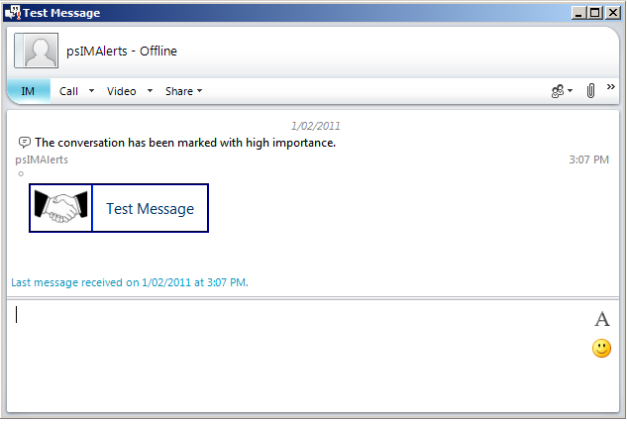
- At the prompt enter: .\ 4-Array.ps1
- To the question of which template enter: globe
- To the question of “Recipient Target Id” enter either the login id, display name , email address or SIP URI of a target account.
Warning: if you are doing this test in a production environment many accounts will get a test IM.
- Repeat step 4 for several Ids. Once all Ids are entered press enter for a blank entry.
- To the question of message text press enter to accept the default text.
- To the question of subject line press enter to accept the default text.
- To the question of sender press enter to accept the default account or enter a SIP URI.
Warning: it is recommend to provide a resource account that does not use IM.
- The Powershell® script is generated, displayed and executed.

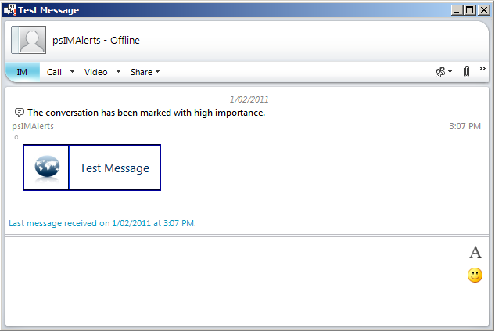
- At the prompt enter: .\ 4-Array.ps1
- To the question of which template enter: time
- To the question of “Recipient Target Id” enter either the login id, display name , email address or SIP URI of a target account.
Warning: if you are doing this test in a production environment many accounts will get a test IM.
- Repeat step 4 for several Ids. Once all Ids are entered press enter for a blank entry.
- To the question of message text press enter to accept the default text.
- To the question of subject line press enter to accept the default text.
- To the question of sender press enter to accept the default account or enter a SIP URI.
Warning: it is recommend to provide a resource account that does not use IM.
- The Powershell® script is generated, displayed and executed.
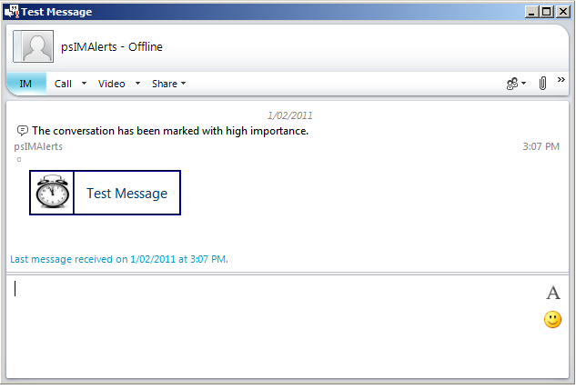
- At the prompt enter: .\ 4-Array.ps1
- To the question of which template enter: winning
- To the question of “Recipient Target Id” enter either the login id, display name , email address or SIP URI of a target account.
Warning: if you are doing this test in a production environment many accounts will get a test IM.
- Repeat step 4 for several Ids. Once all Ids are entered press enter for a blank entry.
- To the question of message text press enter to accept the default text.
- To the question of subject line press enter to accept the default text.
- To the question of sender press enter to accept the default account or enter a SIP URI.
Warning: it is recommend to provide a resource account that does not use IM.
- The Powershell® script is generated, displayed and executed.
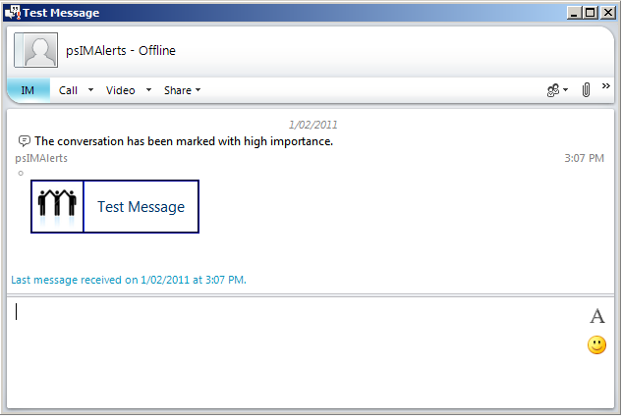
Comments and Rating
Provide your review of the test. Score the quality of the experience.

- Did each of the pictures appear as in the screenshots? (Yes/No)? ____
- Did you experience any error messages (Yes/No)? ____ Comments: __________________
2. Were the instructions clear (Yes/No)? ____ Comments: __________________
4. What was your overall impression of the test (0-Terrible, 5- Fair, 10-Excellent)? ____
Comments: _______________________________________________________

Documentation location
Master Hard copy | Master Electronic
State where stored, or write ‘NA’ if there are no paper copies.

DOCUMENT CONTROL SHEET
The purpose of this section is to capture all changes made to the content of document.
Contact for Enquiries and Proposed Changes
If you have any questions regarding this document or would like to suggest an improvement, contact:
Name | Fred Natzke
Designation | CEO
Phone | 07 41593288
e-mail | Fred.l.natzke@BlueQualityStudios.com.au

Revision History
Version No | Version Date | Nature of Change | Author of Change
1.0 | 7 February 2011 | Initial draft | Fred Natzke

This publication has been prepared and written by Blue Quality Studios (ABN 21 269 363 940), and is copyright. Other than for the purposes of and subject to the conditions prescribed under the Copyright Act, no part of it may in any form or by any means (electronic, mechanical, microcopying, photocopying, recording or otherwise) be reproduced, stored in a retrieval system or transmitted without prior written permission from the document controller. Product or company names are trademarks or registered trademarks of their respective holders.

